Le Petit Déjeuner Nom _______________________________________________
I. Introduction : https://www.youtube.com/watch?v=F9x9sBEyGyA
A. Check the items that are mentioned as being part of a typical French breakfast.
___ Le café
___Les céréales
___Une gaufre
___Le jus de fruit
___Les croissants
___Le lait
___Le thé
___La baguette
___Le toast
___Le beurre
___Les fruits
___Un yaourt
___Le sucre
___ Les œufs
___La confiture

B. Find out how often your partner eats each of these items and check the appropriate box.
Q : Tu prends souvent du/de la/des…
A : Oui, j’en prends…
- Une fois par jour
- Une fois par semaine
- Une fois par mois
Non, je n’en prends jamais.

 | Une fois  par jour | Une fois  par semaine | Une fois  par mois | Jamais
Du café
Des céréales
Des gaufres
Du jus de fruits
Des croissants
Du lait
Du thé
Une baguette
Du toast
Du beurre
Des fruits
Du yaourt
Du sucre
Des œufs
De la confiture

C. Write 5 sentences comparing what you eat for breakfast with your partner’s breakfast habits. Use the following words/phrases in your sentences:
- et (and)
- mais (but)
- moi, aussi (me, too)
- Moi, non plus (me, neither)
- Ni mon partenaire ni moi ne… (Neither my partner nor I…)

1. ________________________________________________________________________________________________
________________________________________________________________________________________________
2. ________________________________________________________________________________________________
________________________________________________________________________________________________
3. ________________________________________________________________________________________________
________________________________________________________________________________________________
4. ________________________________________________________________________________________________
________________________________________________________________________________________________
5. ________________________________________________________________________________________________
________________________________________________________________________________________________
II. Read the article and complete the following interpretive activity. https://karott.egnyte.com/h-s/20131217/d52725a0232f4e06
A. Key Word Recognition. Find the French words/phrases that best express the meanings of the following English words/phrases.

- Every day __________________________________
- On the weekend_____________________________
- Men______________________________________
- A product made of grain_____________________
- A dairy product______________________________
- A fruit____________________________________
- A fruit juice_________________________________
- Lack of appetite____________________________
- Lack of time________________________________

B. Main Idea. What is this infographic about? Write in English.
____________________________________________________________________________________________________________________________________________________________________________________________________
C. Supporting Details. Check each detail that is given in the article. (Not all are mentioned) Then fill in the information that is given for each detail. Write in English.
___The percentage of people in Belgium who eat breakfast every day ____________________________
___The amount of time that Belgians spend on breakfast during the week____________________________
___The amount of time that Belgians spend on breakfast on the weekend____________________________
___The proportion of men between the ages of 25 and 34 who skip breakfast____________________________
___The proportion of teenagers who skip breakfast ______________________________
___The percentage of people who have an item made of grain for breakfast____________________________
___The percentage of people who have a dairy product for breakfast____________________________
___The percentage of people who have coffee for breakfast __________________________
___The percentage of people who have fruit or juice for breakfast____________________________
___The reasons that people skip breakfast_______________________________________________________________
______________________________________________________________________________________________
___Diseases that people who eat breakfast are less likely to get____________________________
___Items in a healthy breakfast____________________________
___Types of breakfast ingredients that aren’t healthy____________________________
D. Guessing Meaning from Context. Find the underlined words/phrases and write what you think they mean in English.
1. 94% prennent un produit céréalier
2. 1/3 des hommes entre 25 et 34 ans sautent le petit-déjeuner ___________________________
3. produits riches en graisses et en cholestérol_____________________________
E. Inference. Answer the following question in English, giving as much information from the article as possible to support your response.
1. Why do you think that Belgians don’t eat eggs, pancakes, or bacon for breakfast? ______________________________
____________________________________________________________________________________________________________________________________________________________________________________________________
F. Comparing Cultural Perspectives. Answer the following question in English.
1. How is a typical American breakfast different from a typical Belgian breakfast? Why do you think this is? ______________________________________________________________________________________________________________________________________________________________________________________________________________________________________________________________________________________________________
III. Watch the video and answer the questions in English. ( https://www.youtube.com/watch?v=kNYuRwnqtm4 )
1. What other countries’ breakfasts have these students already tried? ________________________________________
2. What grade is Marianne in? (Listen for 2 letters and a number) ________________________________________
3. According to the reporter, what did they taste this morning? ______________________________________________
__________________________________________________________________________________________________
4. What did Marianne think of the breakfast? _____________________________________________________________
5. What does she usually have for breakfast? _____________________________________________________________
__________________________________________________________________________________________________
6. Who is Sophie? ___________________________________________________________________________________
7. According to Sophie, what countries’ breakfasts did the other classes have? __________________________________
__________________________________________________________________________________________________
Communication Interpersonnelle. Ask your partner the following questions and circle his/her answers.
1. Tu prends le petit déjeuner tous les jours? Oui Non
2. Pourquoi est-ce que tu sautes le petit déjeuner ?
- Je n’ai pas le temps.
- Je n’ai pas faim. (manque d’appétit)
- Je n’ai pas l’habitude.
3. Qu’est-ce que tu prends comme petit déjeuner ?
- Un café
- Un bol de céréales
- Une gaufre 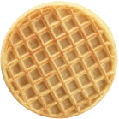
- Un jus de fruits
- Un fruit
- Une barre de céréal
- Des œufs 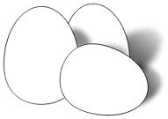
- Un yaourt
- Du toast/pain grillé
Autre : _________________________________________________________________________________________
IV. http://www.dailymotion.com/video/xa76eu_le-petit-dejeuner_lifestyle )
- The time it is in this video?
- The narrator says “ Comme d’habitude Paul part au collège sans petit déjeuner. What do you think sans means?
- What does Garance have for breakfast?
- What does their mother have?
- According to the dietician, why is breakfast important?
- What is the first food group that is mentioned?
- Why is this item important?
- What example is given for this food group?
- What is the next food group that is mentioned?
- Why is this group important?
- What examples are given?
- Why is it important to have a piece of fruit or fruit juice?
- What percentage of your energy needs are met at breakfast?
- When will you get hungry if you don’t eat breakfast?
- If you don’t eat breakfast, what might you end up snacking on?
- According to the narrator, these items are “trop riches en matières grasses.” What do you think matières grasses are?

Devinez Qui
1. You and your partner will each choose one of the following identities without telling the other whom you have chosen.
2. Take turns asking each other yes/no questions about what you’re having for breakfast in order to guess which identity your partner has chosen.
3. The winner is the first person to correctly guess his/her partner’s identity.
Q: Tu prends…?
A. Oui, je prends… OR Non, je ne prends pas de …
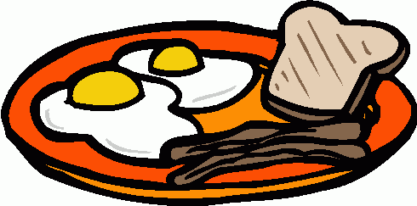 | 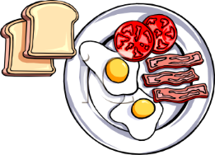 | 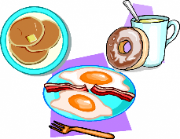 | 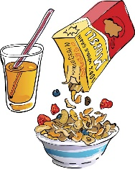 | 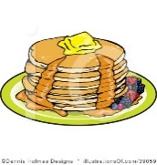
Ali | Sophie | Marianne | Patrice | Yusuf
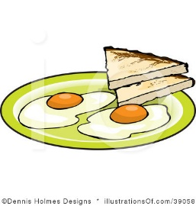 | 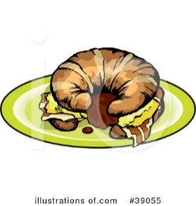 | 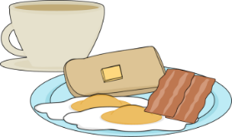 | 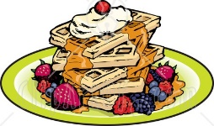 | 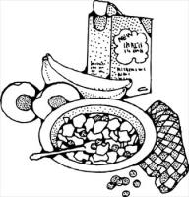
Matthieu | Amina | Edouard | Lisette | Alexandre
 | 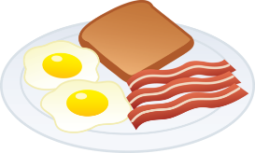 | 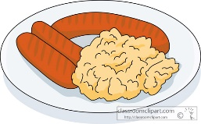 | 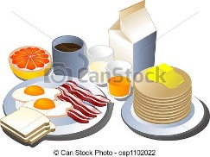
Pierre | Philippe | Sandrine | Louise | Charlotte
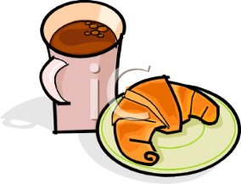 | 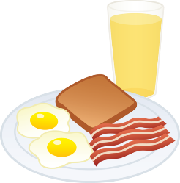 | 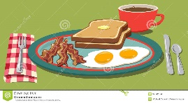 | 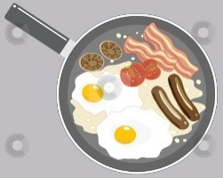 | 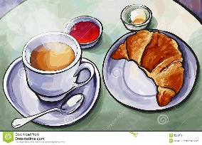
Luc | Sarita | Asiya | Lucien | Michel
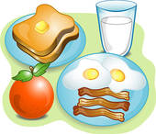 | 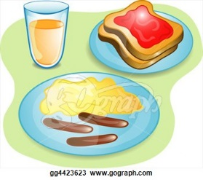 | 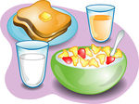 | 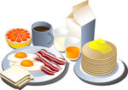 | 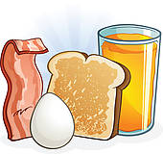
Paul | Tiphaine | Nanette | Bruno | Gustave

Présentation. Write a paragraph about your breakfast habits in which answer the following questions:
- Tu prends le petit déjeuner en semaine? Pourquoi ou pourquoi pas ?
- Si oui, ou est-ce que tu le prends ? (A la maison ? A l’école ?)
- Qu’est-ce que tu manges comme petit déjeuner ?
- Tu prends le petit déjeuner le weekend ? Pourquoi ou pourquoi pas ?
________________________________________________________________________________________________________________________________________________________________________________________________________________________________________________________________________________________________________________________________________________________________________________________________________________________________________________________________________________________________________________________________________________________________________________________________________________________________________________________________________________________________________________________________________________________________________________________________________________________________________________________________________________________________________________________________________________________________________________________________________________________________________________________________________________________________________________________________________________________________________________________________________________________
V. Read the article and answer the following questions in English.( http://www.le-petit-dejeuner.fr/petit-dejeuner-americain.php )
1. According to the article, which countries’ breakfast habits most influenced the United States? ___________________
________________________________________________________________________________________________
2. What sweet foods are mentioned as being part of a traditional American breakfast? ___________________________
__________________________________________________________________________________________________
3. What savory items are mentioned? ___________________________________________________________________
__________________________________________________________________________________________________
4. What beverages are mentioned? _____________________________________________________________________
5. According to the article, how is American coffee different than French coffee? ________________________________
__________________________________________________________________________________________________
6. Find the following French words and phrases in the article:

- A mixture _____________________________
- Maple syrup ___________________________
- Oatmeal _______________________________
- A scrambled egg _________________________
- A fried egg _____________________________
- Cranberry ______________________________
Activité Interpersonnelle. Ask your partner whether s/he has had each of the following foods and drinks during the past week and check each one that she has had to eat or drink.
Q: Tu as pris …? (Did you have…?)
A: Oui, j’ai pris … (Yes, I had…) OR Non, je n’ai pas pris de…

___ un pancake
___ une gaufre
___ un muffin
___ du yaourt
___ des céréales
___un fruit
___ une omelette
___ un œuf brouillé
___ un œuf au plat
___ du bacon
___ une saucisse
___ un jus de pomme
___ un jus d’orange
___ un jus de canneberge
___ un verre de l’eau
___ un café parfumé

Présentation. Fill in the graphic organizer with typical breakfast foods in the U.S., France, and both countries. Write in French.
Les Etats-Unis | Les Deux | La France

